# Exercises about dynamic volumes and mount point folders

1. Create the necessary volumes and disks to gain the information below.

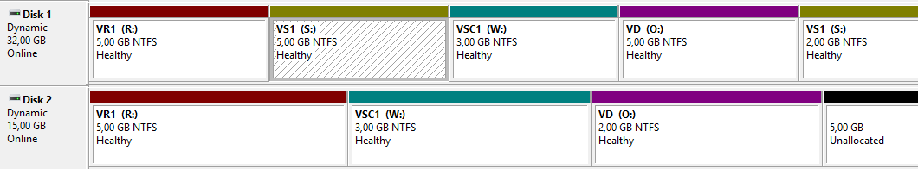

IMPORTANT: There are two volumes with partitions of equal size. VR1 (5 GB for partition) will be fault tolerant. Regarding VSC1 (3 GB for partition), it will not be fault tolerant, but you should opt for the volume in which the data is managed in the most efficient way.

Mirrored volume VR1: V:\ is a 2048 MB mirrored volume

Simple volume VSC1: X:\ first 1024 MB and extend up to 3027 (the extend is at the end of the HD where the unallocated spaced is)

Striped volume VSC1: I:\ 3027 MB.

Spanned volume VD: W:\ is a 4096 MB spanned volume (3072 MB in disk 5 and 1024 GB in disk 6)

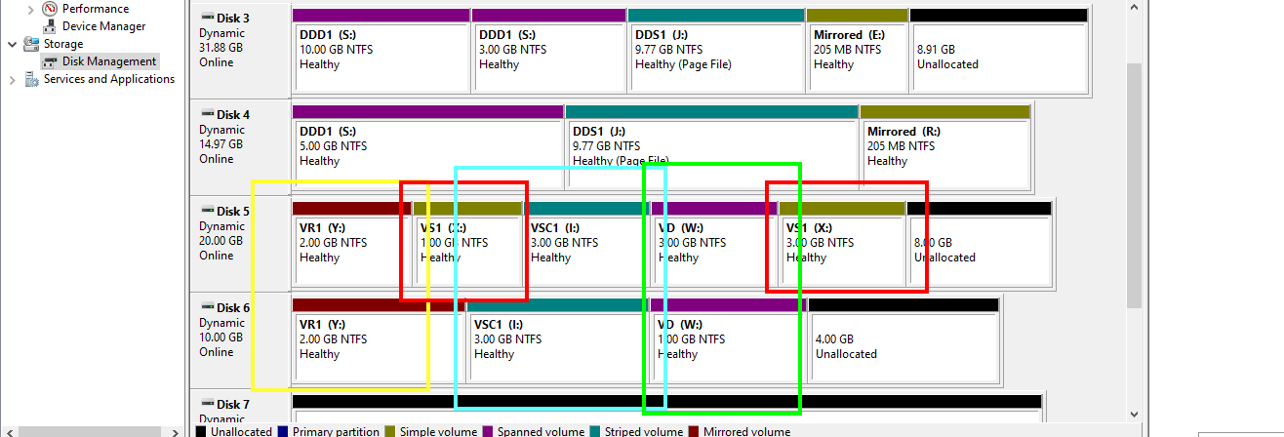

1. Modify the volume labelled as VS1 so that it can only be accessed through a folder called “Simple volume” placed in C:

First, create the folder “Simple volume” in C

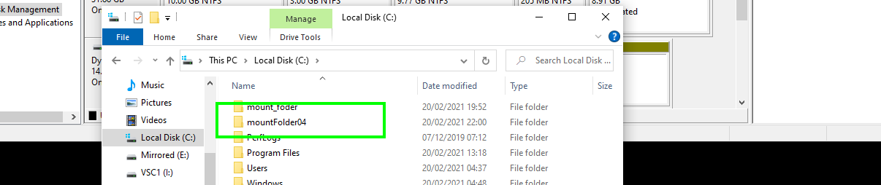

Right click on volume S:\ and click “Change Drive Letter and Paths”

You will need the configuration below

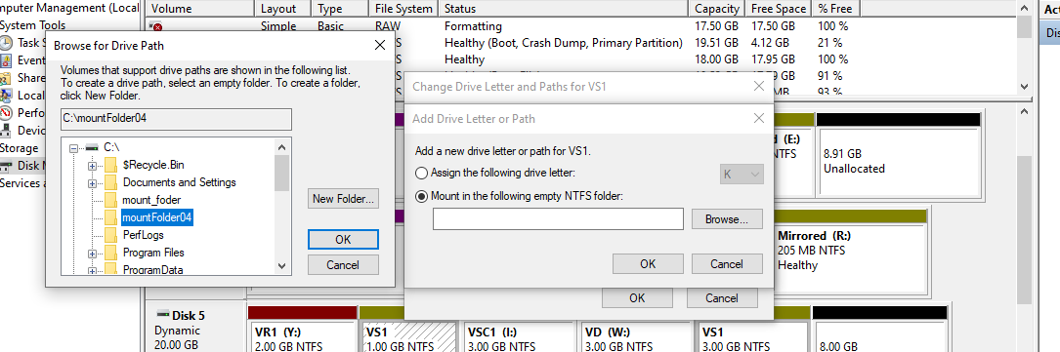

As a result, the content of the folder will be as follows:

